1.

|  |  |  |  |  |
| --- | --- | --- | --- | --- |
| **Parameters** | **bill_length_mm** | **bill_depth_mm** | **flipper_length_mm** | **body_mass_g** |
| Min | 32.1 | 13.1 | 172 | 2700 |
| 1st Qu | 39.5 | 15.6 | 190 | 3550 |
| Median | 44.5 | 17.3 | 197 | 4050 |
| Mean | 43.99 | 17.16 | 201 | 4207 |
| 3rd Qu | 48.6 | 18.7 | 213 | 4775 |
| Max | 59.6 | 21.5 | 231 | 6300 |

The average body mass of the species was 4207g with a minimum of 2700g and maximum of 6300g.

The species bill length averaged 43.99mm, ranging from 32.1 mm to 59.6.

The bill depth ranged from 13.1mm to 21.5mm with an average of 17.16mm

2.

|  |  |  |  |
| --- | --- | --- | --- |
| **species** | **depth** | **length** | **body_mass** |
| Adelie | 18.35 | 38.82 | 3706.16 |
| Chinstrap | 18.42 | 48.83 | 3733.09 |
| Gentoo | 15.00 | 47.57 | 5092.44 |

On average, Gentoo had the highest body mass (5092.4 g), Chinstrap had the highest bill_length (48.83 mm) and bill_depth of 18.42 mm.

3.

|  |  |  |  |  |
| --- | --- | --- | --- | --- |
| **Variables** | bill_length_mm | bill_depth_mm | flipper_length_mm | body_mass_g |
| bill_length_mm | 1.00 | -0.23 | 0.65 | 0.59 |
| bill_depth_mm | -0.23 | 1.00 | -0.58 | -0.47 |
| flipper_length_mm | 0.65 | -0.58 | 1.00 | 0.87 |
| body_mass_g | 0.59 | -0.47 | 0.87 | 1.00 |

There is a positive relationship between bill length and body mass, bill length and flipper length, body mass and flipper length. However, there is a negative relationship between bill length and bill depth, flipper length and bill depth and finally mass boy with bill depth.

4.

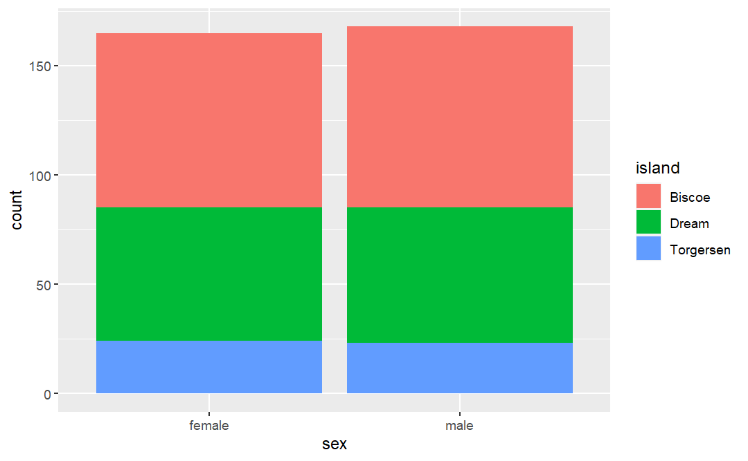

Male species were more in number compared to the female ones. Most of these species were located in the Biscoe Island, followed by the dream island and few lived on the Torgersen island.